# ECE 162 Lab Report Template

Name: Nick Lacroce ([nal414@lehigh.edu](mailto:nal414@lehigh.edu))

## Purpose

“In this lab we will be examining the process of electrolysis.”

## Theory

* *Here I am looking for you to pull knowledge from the book. List relevant equations. Explain the science of WHY it works. This is not the “I think this is going to happen” kind of theory. Think*
* *An example theory is as follows:*

“Electrolysis is the process by which a non-spontaneous chemical reaction is initiated by the application of a DC voltage potential. The mechanism behind this is the idea of potential energy. In chemical bonds, a certain excitation energy is needed to excite the molecules out of their potential wells so they can break down into lower energy states. The application of DC voltage potential provides potential energy to initiate this reaction.

Relevant to the process are Faraday’s laws of electrolysis. The first law is that the quantity of elements separated by electrolysis iis equal to the electrochemical equivalent of the metal deposited or gas liberated at the electrode, times the total charge applied. Or

$$m=eQ$$

Faradays second law is that if the same amount of current goes through multiple electrolysis setups in series, the mass of substance freed/deposited is directly proportional to their equivalent weight.

By these properties, we can predict, and manipulate the results of electrolysis driven chemical reactions.”

## Experimental Method

* *List the steps to your experimental setup here*
* *This should cover all the steps from construction to data collection and measurement*

## Diagram

* *Here I am looking for both a physical diagram and a schematic diagram as seen here.* 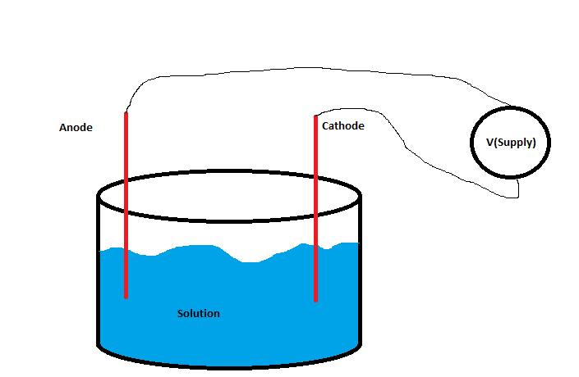

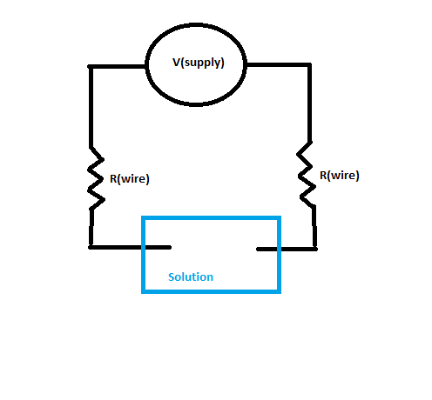

***Notes:***

* + *Here is a good link from Sparkfun with circuit schematics, and how to read them. In general Sparkfun is a good source for tutorials on electronics related projects.*
  + [*https://learn.sparkfun.com/tutorials/how-to-read-a-schematic*](https://learn.sparkfun.com/tutorials/how-to-read-a-schematic)
  + *These are the symbols you should use to draw your diagram. For AVO/Multimeters, use a “voltage source” or “amperage source” labeled “multimeter” or “AVO”*

## Results

* *If you’re going to use either your measured or theoretical values for components, please let me know which.*
* *Please include equations used, recorded values, calculations, and results.*
* *Later on this will include screenshots and graphs.*
* *Use proper units*

## Discussion

* *This is the informal discussion portion of the lab. Mention lessons learned, possible sources of error, whether things went according to plan, interpretation of your results, and discuss things that went wrong and why.*

## Conclusion

* *Wrap up your project with a few sentences to a paragraph. Restate your findings in general, and the project purpose*